Prepared by: Ken Shonkwiler – OMEGA
Prepared for the Musking County Engineers Office
Dillon Falls/Dillon School Road
and
Licking Road
RSA Recommendations

Table of Contents
Introduction 3
Audit Team 4
Background Information 5
Assumptions 6
Site Visits 7
Observations and Recommendations 8
General Recommendations for “Over the Hill” and Licking Road 9
Specific Recommendations- Dillon Falls Road 10
Specific Recommendations- Dillon School Road 12
Specific Recommendations- South Licking Road 13
Appendix A 14

Introduction

The Muskingum County Engineering Office (MCEO) and the Ohio Mid-Eastern Governments Association (OMEGA) conducted a Road Safety Audit for Dillon Falls/ Dillon School Road (commonly known as “Over the Hill”) and Licking Road. These roads were chosen based on their crash history, public opinion of safety, and the condition of the safety signs and infrastructure. This document describes the RSA and the recommendations that the RSA Team has made to the MCEO.
“Over the Hill” describes two main sections of roadway: Dillon Falls Road and Dillon School Road. The MCEO asked us to examine these two sections because they represent a “through-route” for locals and because of their recorded high crash rates. Dillon Falls Road begins at its intersection with Jersey Ridge Road and is close to US 40. It ends at Dillon School Road, and this roadway connects to SR 146 in two separate locations. It was apparent that, after talking with the RSA team and investigating data from ODOT, Licking Road should also be included in the RSA. The map below shows the roadways and their inclusion on ODOT’s High Risk Rural Roads (HHRR) list.
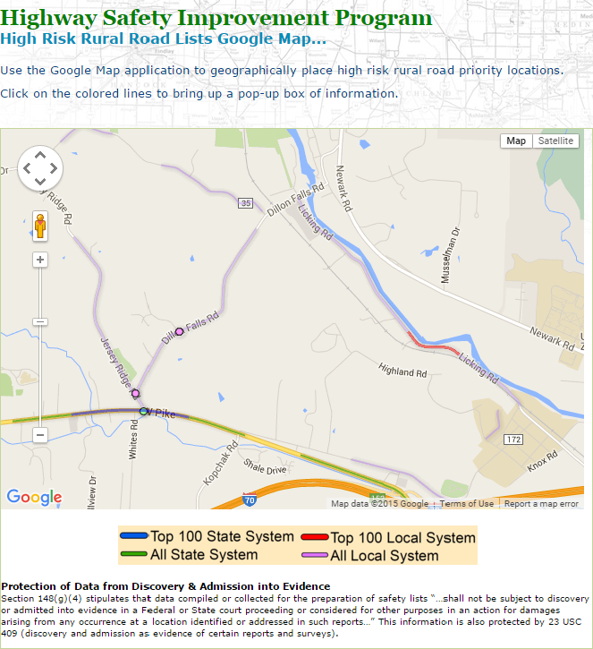

Audit Team

Name | Organization | Routes Audited
Ken Shonkwiler | OMEGA | Dillon Falls/ Dillon School Road; Licking Road
Victoria Beale | ODOT/LTAP | Dillon Falls/Dillon School Road
Kris Bell | Zanesville/ Muskingum Co. Health Department | Dillon Falls/Dillon School Road; Licking Road
Jeff Jadwin | Muskingum County EMA | Dillon Falls/Dillon School Road; Licking Road
John Ryan | ODOT District 5 | Dillon Falls/Dillon School Road; Licking Road

Background Information

The project initiated on September 29th, 2015 when Kris Bell, Ken Shonkwiler, Jeannette Wierzbicki (OMEGA), and Sandie Mapel met to discuss possible areas to conduct an RSA in Muskingum County. On this day, the “Over the Hill” route and the RSA Team was chosen.
The RSA Team met on November 2nd, 2015 at the MCEO. The team took a quick drive along the route and made general observations. Following this, the team returned to the MCEO and then reviewed data along the roadway. The group reviewed the study area, AADT, HRR areas, and crash data.
Crash data was analyzed through 2012 to 2014, and the group examined the data based upon: year, severity, day, hour, month, type of crash, light condition, location, road condition, road contour, contributing factors, driver action, and alcohol related crashes. Based upon local knowledge of the RSA team, it was suggested that age (specifically youth) also be analyzed, and the RSA team found that young adults were involved in nearly 45% of the crashes. Crash data was further analyzed based on youth driving.
Additionally, Victoria Beale provided nighttime dashboard footage of the route, which was reviewed during the RSA. The group utilized the dashboard footage to experience nighttime driving conditions. The footage, crash data, and RSA packet is available upon request.
The RSA team decided to add Licking Road to the “Over the Hill” RSA for three reasons: Licking Road’s proximity to Dillon Falls, the route is another “through route” for local drivers, and the roadway’s crash data (high frequencies, fatalities). Additionally, the RSA Team felt that it should also be included due to the roadway’s Top 100 ranking on HRRR. The MCEO approved of adding Licking Road to the RSA.

Assumptions

Assumptions of the roadways were based upon the following:
- The information provided at the organizational meeting, discussed during the RSAs themselves, researched on ODOT sites (GCAT) during the RSA, and afterwards during the recommendations compilation meetings.
- Visual inspections of the RSA Team.
- Video taken of the corridors by the team during the RSA and video taken by Victoria Beale, whose recordings were taken within days of the RSA.

Site Visits

Visit Number | Corridor | Date of Audit | Time of Audit | Weather
- Initial Visit | Dillon Falls/Dillon School Road | 11/02/15 | 8:45 to 9:30 | Clear and Sunny
- Second Visit | Dillon Falls/Dillon School Road | 11/02/15 | 10:30 to 11:30 | Clear and Sunny
- Second Visit Part 2 | Licking Road | 11/02/15 | 11:30 to 12:15 | Clear and Sunny

Observations and Recommendations

Based on the background information and the site visits to the roadways, several observations and recommendations were compiled by the project team for each segment. Observations and recommendations were recorded as “general” (those that exist along the entire roadways) and specifically on locations along the roadway (intersections, bridges, curves). Appendix A is a map that identifies these specific locations with their corresponding numbers.

General Recommendations for “Over the Hill” and Licking Road

The following are recommendations that are applicable to the entire roadways examined in the RSA, and include recommendations that are both infrastructure and non-infrastructure related.
- Ball Bank roads.
- More attention to snow and ice removal.
- Advocacy with Zanesville-Muskingum County Health Department in West Muskingum High School and Zane State for safe driving campaigns.
- Increased law enforcement on roadway during peak hours of crashes (4:00 to 6:00 pm).
- Retro-reflective Striping on entire roadways.
- Investigate proper locations for “School Bus Stop Ahead” signs. Replace all existing “School Bus Stop Ahead” signs if still warranted.
- Further review crash reports, identify spot locations to improve edge drop offs.
- Tree removal over/along roadway on entire route.
- Investigate traffic timing signals with ODOT at Dillon School Road/ SR 146.
- Replace guardrail along Licking Road. Investigate if guardrail along river is feasible, and install where feasible.
- Systematic sign upgrade along entire roadway. Retro-reflective signs on all existing signage.
  - Intersection signs.
  - Curve signs.
  - Fixed Object signs.
  - Sign post reflectors.
  - Double up on warning signs.
  - Guardrail reflectors

Specific Recommendations- Dillon Falls Road
Map Number | Location | Current State | Suggested Countermeasures | Maintaining Agency
1 | Culvert 0.25 mile | - Culvert on edge of road | - Install retro-reflective fixed object signs on both sides of culvert in both directions. | MCEO
2 | Culvert 0.59 mile | - One damaged fixed object sign.  - Vegetation overgrowing culvert. | - Install retro-reflective fixed object signs on both sides of culvert in both directions.  - Trim vegetation | MCEO
3 | Donkey Farm Curve 0.73 mile | - Fence is close to roadway.  - One curve warning sign  - Few chevrons/ non reflective.  - Degraded roadway striping.  - Lots of left of center travel. | - Ball bank curve for possible speed reduction.  - Dual advanced curve warning signs on both directions of travel.  - Determine ROW for fence locations  - Upgrade chevrons  - Optical speed bars to slow vehicular travel | MCEO
4 | Pinecrest Intersection 1.29 mile | - Chevrons are non-reflective  - Large trees in ROW, high vegetation in ROW. | - Dual advanced curve warning/ intersection signs with street plaque below sign.  - Upgrade chevrons.  - Remove large trees and stumps in ROW west of intersection.  - Trim vegetation.  - Fixed object signs in front of fire hydrant  - Fix slanted fire hydrant | MCEO/  Muskingum County EMA
5 | Railroad Bridge 1.3 mile | - Tree canopy over bridge entrance.  - Ditches close to edge. | - Cut tree canopy over bridge entrance.  - Fixed object signs both directions of bridge.  - Investigate ditch enclosure around entrances/exits of bridge. | MCEO
6 | Licking Road Intersection  1.49 mile | - Little visual information of upcoming intersection.  - Signage is not both directions for intersections.  - Signage not very visible. | - Install stop condition ahead signs for both directions  - Road name plaque on intersection signs  - Signs indicating the EMS and Firehouse location/travel  - Upgrade fixed object reflectors | MCEO
7 | Bridge  1.52 mile | - No signage warning bridge conditions. | - Bridge ice warning sign, either fold-up or non-folding warning sign | MCECO
8 | Dillon School Intersection  1.7 mile | - Double arrow sign is worn.  - Lacking information on the upcoming intersection.  - Lots of congestion at intersection | - Upgraded double arrow sign  - T intersection ahead sign  - Long term: Round-a-bout | MCEO

Specific Recommendations- Dillon School Road
Map Number | Location | Current State | Suggested Countermeasures | Maintaining Agency
9 | North curve  .34 | - Little visual information of upcoming intersection.  - Chevrons need upgraded.  - Check recommended speed – might be too low. | - Ball bank curve for correct speed reduction  - Advanced intersection warning for Perry Lane  - Chevrons both directions  - Guardrail reflectors | MCEO
10 | Dillon Falls Intersection – Both Directions | - No visual information on Dillon Falls traffic patterns.  - Intersection warning signs on south intersection. | - Retro-reflective stop signs  - Advanced intersection warning signs with road plaque name.  - Sign showing Dillon Falls traffic – “Traffic Does Not Stop” | MCEO

Specific Recommendations- South Licking Road

Map Number | Location | Current State | Suggested Countermeasures | Maintaining Agency
11 | Railroad Crossing  1.55 mile | - Pedestrian crossing for factory is unclear.  - Warning sign northbound for pedestrian crossing. | - Designate clear pedestrian walkways to factory.  - Striping for walkway.  - Sign southbound approach for pedestrian crossing at railroad.  - RRFB for crossing.  - Intersection ahead signs. | MCEO
12 | HRRR Top 100 Curve  1.05 mile | - Vegetation over curve.  - Inconsistency with road sign warnings.  - Lacking chevrons.  - Guardrail is in poor condition. | - Install curve warning sign that is representative of curve.  - Remove trees over roadway.  - Chevrons along north part of curve  - Install and/or replace damaged guardrail along curve. | MCEO

Appendix A
